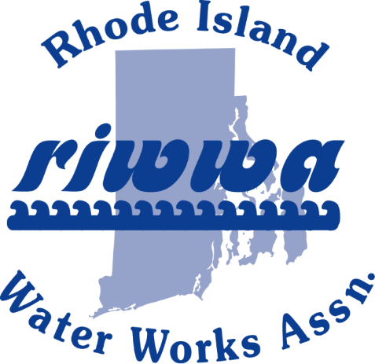

RIWWA 40th Annual Golf Tournament

Sponsor Form
Valley Country Club
Thursday, October 15, 2020

RIWWA has the following sponsor opportunities for the 40th Annual RIWWA Golf Tournament at Valley Country Club on Thursday, October 15, 2020. Anyone who would like to donate raffle prizes can bring them to the registration table on the day of the event. RIWWA appreciates the continued support of our sponsors in helping make this event a success!!!
Date: | Contact Name:
Company Name:
Mailing Address:
City: |  | State: | Zip:
Phone: |  | Cell Phone: | Fax:
E-Mail:

Sponsorship Levels:
Dinner Sponsor - $250 (Limit of 6)
Sign with sponsor logos at each dinner station
In-Cart Digital Advertising - $200 (Limit of 18) NEW THIS YEAR
Showcase your business advertisement in every cart for one of the 18 hole
BBQ Lunch Sponsor - $200 (Limit of 6)
Sign with sponsor logos at BBQ station
Post-Golf Appetizer Sponsor - $200 (Limit of 4)
Sign with sponsor logos in area of post-golf appetizer station
Soft Drink/Bottled Water Sponsor - $150 (Limit of 4)
Sign with sponsor logos at soft drink/water cooler locations
Tee Sponsor - $100 for 1st sign and $50 for each additional
Signs with sponsor logos in tee box
Please email logos to decelles@pwsb.org
Number of Signs Requested Tee sign amount $
Total Sponsor Amount $

E-mail your company logo to decelles@pwsb.org in a PDF or JPEG Format
Method Of Payment
Amount Paid: | Cash: | Credit Card: | Check No.:
Visa: | Master Card: | Discover: | American Express:
Card Number:
Expiration Date: |  | Security Code: | Card Zip Code:
Mail this form and payment to: RIWWA, P.O. Box 216, West Kingston, RI 02892
Confirmation and payment must be submitted by Monday, September 21, 2020
FIRST COME, FIRST SERVE ON SPONSORSHIPS

